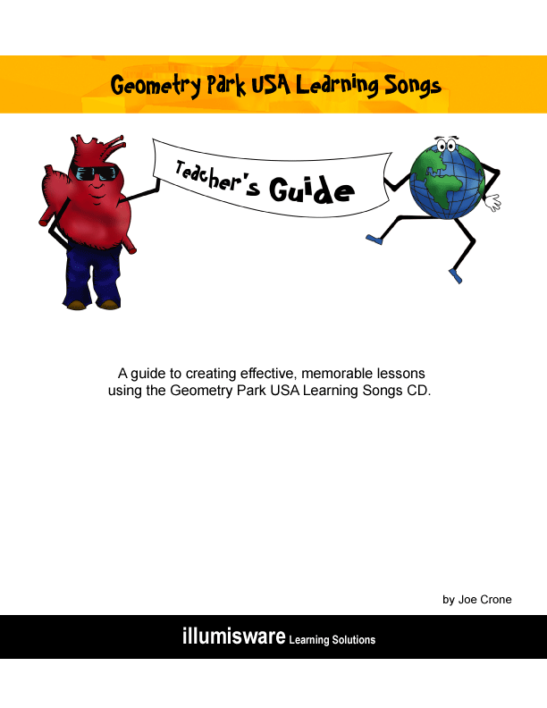

1. The Language Police

Activity 1: Music and Drama

Objective: Students will dramatize the song “Language Police”

Materials: The materials needed, will depend on the drama created by the class during the brainstorming sessions.

Method: Listen to the song a couple of times. As a class, brainstorm the ideas that the students have. Record them on chart paper. There may be several good ideas, but as a class you need to only focus on the one that is chosen. This is a great exercise in detachment. Make sure the students understand that in drama it is not about who gets what part, or whose idea is used, but rather it is about working together as a collective whole to create unity, and therefore an effective drama. After you’ve got the story of your drama, list the props that will be needed for each scene. You may need a desk for the police chief, wanted posters, a cardboard house for the final scene where the criminals are surrounded. Decide who is going to make or bring in what. Either learn the song as a group, or have a few of your students sing it while the others act it out.

Activity 2: Art

Objective: Students will create wanted posters for Noun, Verb, Adverb, and Adjective.

Materials: Poster paper, pencils, markers, pastels.

Method: This one’s pretty simple. Students can either create a complete set themselves, or get into groups of 4 in order to make a complete set. Make sure that the students list all the qualities of each character on the poster. If you are going to place them in the hall of the school, it’s always funny to draw a few of the wanted characters so that they closely resemble some of the other staff members.

2. Fraction Rock

Activity 1: Music and Drama

Objective: Students will dramatize the song “Fraction Rock”.

Materials: The materials needed, will depend on the drama created by the class during the brainstorming sessions.

Method: The method is the same as described in “The Language Police”. Listen to the song a couple of times. As a class, brainstorm the ideas that the students have. Record them on chart paper. There may be several good ideas, but as a class you need to only focus on the one that is chosen. This is a great exercise in detachment. Make sure the students understand that in drama it is not about who gets what part, or whose idea is used, but rather it is about working together as a collective whole to create unity, and therefore an effective drama. After you’ve got the story of your drama, list the props that will be needed for each scene. You may need desks for the teacher and students, a blackboard, and other “classroom” items. Either learn the song as a group or have a few of your students sing it while the others act it out.

This song is fairly straight forward. It tells a story. All you need to do is act out the story. The costumes and props are minimal. When I sing the song I always involve the audience in the chorus by having them place their hands on their head as they sing “Be like a rabbit and multiply”. For the chorus , “Be like an amoeba and divide”, I instruct the audience to clasp their hands in front of them and then slowly pull them apart, mimicking the reproduction of a single cell amoeba. You may wish to do this too.

3. Slip to the Side

Activity 1: Music, Drama and Dance

Objective: Students will perform the “Slip to the Side”.

Materials: Rap, hip hop clothing.

Method: This is a straight song and dance number. If you don’t have a dance background, it’s a sure bet that at least some of your students watch music videos and can imitate some dance moves. I originally wrote this song as an echo, or call and response song. It still works that way rather nicely if you want to include your audience. Sing, dance and have fun.

4. Producers/Consumers

Activity 1: Music and Drama

Objective: Students will dramatize the song “Producers/Consumers”

Materials: The materials needed, will depend on the drama created by the class during the brainstorming sessions.

Method: The method is the same as described in “The Language Police”. Listen to the song a couple of times. As a class, brainstorm the ideas that the students have. Record them on chart paper. There may be several good ideas, but as a class you need to only focus on the one that is chosen. This is a great exercise in detachment. Make sure the students understand that in drama it is not about who gets what part, or whose idea is used, but rather it is about working together as a collective whole to create unity, and therefore an effective drama. After you’ve got the story of your drama, list the props that will be needed for each scene. Decide who is going to make or bring in what. Either learn the song as a group or have a few of your students sing it while the others act it out.

I had a class one year that dramatized this song for a holiday assembly. The students were in great costumes and were on stage in either their producer, consumer, or decomposer groups. The lions ended up consuming a poor unsuspecting cow while the scavengers, a vulture and person rooting around a garbage can, anxiously looked on. The little cow, with legs stiff and held straight in the air, was dragged offstage by the scavengers. The drama ended in a chorus line affair, with the little cow back on stage, on its back, legs still held straight up.

5. The Beat Goes On

Activity 1: Creative Writing

Objective: Students will write a story using the circulatory system as the setting. Their story must clearly demonstrate understanding of the various parts and functions of the circulatory system.

Materials: Paper and pencil

Method: Students will study the circulatory system and become familiar with its various parts and functions. They will then create a story that will use the circulatory system as the setting. Students may work in pairs or individually. Any idea is good as long as it serves the purpose of illustrating the functions of the various components of the circulatory system. If they are stuck, you may ask them to compare the functions of the different components of the system to things around them in the world. For example, the red blood cell may be compared to a delivery, or transport truck, the white blood cells may be thought of as police cars as they track down thieves, the small intestines may be a donut shop or restaurant, the lungs as a gas station, or clear unpolluted mountain air, the veins and arteries may be a race track or freeway, etc. This will help them come up a story. Go through the writing process with your students, giving them opportunities to share their writing. Their stories may become the basis for a class drama. See activity 2.

Activity 2: Music and Drama

Objective: Students will take the audience on a musical journey through the circulatory system by tracing the path of a red blood cell as it travels through the body.

Materials: The materials that will be needed will depend on the story chosen to be acted out by the class.

Method: Students will study the circulatory system and become familiar with its various parts and functions. The drama can take many different forms. Students may try to share their understanding of the circulatory system in a “realistic” way by using their bodies to mimic the various sections of the system and their functions. For example, students may all wear red T shirts, link arms, form a four chambered heart and squeeze the red blood cells from the right atrium to the right ventricle, etc.. The setting could be a scientist’s lab as he or she communicates with the red blood cells while they travel through the circulatory system. The red blood cells can report back to the scientist during different parts of their journey, letting the audience know what is happening to them along the way. Another idea for this kind of dramatization is, rather than have the blood cells report back to the scientist, your students could sing “The Beat Goes On” while they dramatize the circulatory system. You can use a video camera and create your own music video.

Students may choose to be more abstract in their dramatization of the circulatory system by using one of their stories as the basis for a whole class drama. For example, instead of portraying the small intestines as a tube where nutrients are taken by the blood cells, they may open the “Small Intestine Donut Shop and Café”. Your students may decide to show it as a donut shop where truckers, i.e. red blood cells, are stopping for nutrients. Make sure the audience can clearly identify each component of the circulatory system during the students’ drama. The students can perform “The Beat Goes On” at the end of their drama.

Activity 3: Art

Objective: Students will create a life sized cardboard cut out illustrating the path and function of the circulatory system.

Materials: Cardboard, brass fasteners, blue and red yarn, containers that are of a suitable size for lungs, e.g. empty plastic pop bottles, and containers that are of suitable a suitable size for the creation of a 4 chamber heart. Hot glue, glue guns, and white glue.

Method: Students will study the circulatory system and become familiar with its various parts and functions. They will cut out life sized limbs, torso, neck, and head. They will then fasten the body parts together with brass fasteners. This is so the model can move. Using a diagram from a text as a reference, students will use hot glue to attach their lungs and 4 chambered heart to the model. They will then use red yarn and white glue to trace the path of oxygenated blood from the lungs, back to the heart, and out to the cells of the body. The blue yarn will be used by students to trace the path of deoxygenated blood back from the cells of the body, to the heart, and back out to the lungs. While singing the song “The Beat Goes On”, the students will trace the path of blood through the body. One year a particularly creative group of students in my class used their model’s movable limbs to create a dance routine. Group members were responsible for moving certain limbs, and their model actually danced to the song while one student traced the path of blood.

6. Digestion Blues

Activity 1: Creative Writing

Objective: Students will write a story using the digestive system as the setting. Their story must clearly demonstrate understanding of the various parts and functions of the digestive system.

Materials: Paper and pencil

Method: Students will study the digestive system and become familiar with its various parts and functions. They will then create a story that will use the digestive system as the setting. Students may work in pairs or individually. Any idea is good as long as it serves the purpose of illustrating the functions of the various components of the digestive system. If they are stuck, you may ask them to imagine themselves as a piece of food. What would they be seeing, thinking, touching, hearing, smelling, thinking and feeling as they travelled through every component of the digestive system? This is a really fun exercise. It will help them come up a story. Go through the writing process with your students, giving them opportunities to share their writing. Their stories may become the basis for a class drama. See activity 2.

Activity 2: Music and Drama

Objective: Students will take the audience on a musical journey through the digestive system, by tracing the path of food as it travels through the body.

Materials: The materials that will be needed will depend on the story chosen to be acted out by the class. The story that I will describe below will need the following items: 3 small “lego men”, a science lab coat, plenty of red T shirts, some white T shirts, plant spray bottles, something that looks like a “shrink ray”, and any paraphernalia desired to create a laboratory setting.

Method: Students will study the digestive system and become familiar with its various parts and functions. The drama can take many different forms. I will describe a drama that a class of gr. 5 students did to share their understanding of the circulatory system in a “realistic” way. For this drama I had my class divided into groups. Each group was given the task to dramatise a component of the digestive system, keeping in mind its appearance and function. They then shared their ideas with the rest of the class. The other students gave positive feedback to the groups. I gave additional suggestions, or asked students for suggestions, if the group had difficulty clearly demonstrating the function of their assigned body part. For example, how can the small intestine clearly demonstrate the taking of nutrients from the chyme? What can the students portraying the small intestine do to illustrate this? How does the passing chyme feel when this happens to it? What is its emotional state, what should it be saying, and what kind of body language should it have as nutrients are drained from it? Students used their bodies to mimic the various sections of the system and their functions. For example, students wore red and white T shirts, and had squirt bottles to mimic the action of the mouth.

We chose to create a story around our digestive system exploration. The setting that was chosen was a scientist’s laboratory. The scientist was experimenting with his newly invented shrink ray, when he accidentally shrank himself. He was mistaken for a small “cocktail sausage” by a near-sighted assistant and accidentally eaten. The assistant realized what he had done only after swallowing the scientist. The assistant then called for help and a several volunteers came in from a nearby lab. The assistant then swallowed two volunteer rescuers who chased after the scientist. The rescuers reported back to the growing number of people gathered in the lab during every stage of the digestive system rescue. By the rescuers’ “live, on the spot” reporting and their own conversations with each other, the audience was clearly informed as to the nature and function of each stage of the digestion process. We decided to use a video camera and make a T.V. show out of the drama. The scenes cut back and forth from the lab setting to the rescuers as they entered different parts of the digestive system. As the fearless rescuers finally caught up with the poor scientist at the very end of the large intestine, the camera cut to the scene of the near-sighted assistant running down the school hallway towards the boys’ bathroom. We then filmed the final body “sphincter” scene with the students portraying the large intestine. The nearsighted lab assistant emerged from the washroom after a flush of the toilet with 3 small “lego men” in his hand. After the story was wrapped up back in the scientist’s lab, we sang “The Digestion Blues”. The video made its way to many classrooms and quite a few parents’ homes. Several years after doing this I was in the local mall when I heard a booming male voice shout, “Mr. Crone, I remember when I was an anus in your class.” I just smiled.

Activity 3: Art

Objective: Students will create a life-sized cardboard cut out illustrating the path and function of the digestive system.

Materials: Cardboard, brass fasteners, household junk suitable for mimicking the various components of the digestive system. Hot glue, glue guns, and white glue.

Method: Divide your students into small groups. They will study the digestive system and become familiar with its various parts and functions. In their groups, have them brainstorm various items that they can get from home to serve as models for the different organs that make up the digestive system. Instruct them to use the cardboard to cut out life-sized limbs, a torso, neck, and head. They will then fasten the body parts together with brass fasteners. This is so the model can move. Using a diagram from a text as a reference, students will use hot glue to attach the materials to their cardboard model. The materials must be joined together to mimic the path of the digestive system. The student groups can then trace the path of food through their model’s body while singing the Digestion Blues”. You may also want to assign a couple of student groups at a time to present their models and the song to other classrooms. The performance aspect of sharing work with other classes has many valuable aspects including solidifying knowledge,
building confidence, and educating other students.

7. Geometry Park

Activity1: Art

Objective: Students will create a poster illustrating geometric concepts in the curriculum.

Materials: Paper, pencils, pencil crayons.

Method: Before creating a poster of the different 2 dimensional geometric shapes outlined in the curriculum for your grade, it is important that students fully understand the concepts. I always create a booklet for the students. In the booklet each student needs to write down a definition of each curriculum expectation, and draw 2 examples clearly illustrating an understanding of this concept. The booklet needs to be completed and checked by 2 peers before work on the poster may be started. This works well for split grades. In geometry, there are, usually, only small differences from grade to grade, and you can simply add on the new curriculum expectations for the next grade. The same idea can also be applied for students in an enriched program. Once the booklet has been completed and checked, the students can start on the poster. The expectations for the poster are simple. The student needs to clearly display all the geometric concepts that they are expected to know in their grade level. Make sure you use your grade specific curriculum for your art projects and booklets and not just the concepts listed in “Geometry Park”. Include intersecting lines, translations, rotations, drawing angles of a given dimension, line symmetry, congruency, etc. if they are in your curriculum. I have always had my students make a “blue print” drawing out of pencil. On this drawing the shapes and concepts have to be clearly labelled and identified. These drawings need to be checked by a peer. Students may choose to create an image from the song “Geometry Park”, simply draw shapes for their own sake, or weave it into a drawing about space, or the rainforest, etc. Let their imagination have no bounds. Once the blueprint is complete, they may start on the art copy. This copy is free of labels, and math symbols. When both copies are finished, display them. It’s fun to hang the “blue print” beside the student’s finished art poster. Play “Geometry Park” in the background during work periods occasionally. After you’ve played the version with the vocals a few times, play the karaoke version. You’ll be surprised at how many students will be singing.

Activity 2: Music and Drama

Objective: Students dramatise and sing the song “Geometry Park”.

Materials: Lots of large corrugated cardboard, paint, brushes, elastic, fishing line, a light bouncy ball.

Method: Let me start off by saying that every time I’ve done this it has been a highlight of the year for the students. It’s a great one for assemblies and concerts. Using the song “Geometry Park”, assign characters to your students. If you have more students than characters, you can double up some of the polygons or create other shapes that are hanging out in the park. Please create two basketball hoops. It’s always a laugh when they come dancing out on to the stage for the last part of the song. Have the students create their assigned character out of corrugated cardboard. The bigger the shape is, the more effective it will be. The image that we are trying to create in this drama is one of a real life cartoon. Have your students cut holes out of the center of their shapes. This is for their face. Loop the fishing line through the cardboard at both sides of the hole and attach elastic to it. The students should then be able to wear their shape because of the elastic stretching around the back of their heads. This will allow them to have full use of their hands. After the characters have been completed, the rest is simple. “Geometry Park” tells a story. Act out the story. Either have all your students sing the song, or simply have a small group of singers from your class sing the story. Make sure the polygon gang makes a dramatic entrance

8. Capitals are a Strange Thing

Activity 1: Art and Games

Objective: Students will create a card game that will teach the rules for the use of capital letters.

Materials: Black line master in appendix B, fine tipped markers.

Method: Use the black line master in appendix B to create playing cards for the class. Photocopy the master on to hard card stock paper. The images that I’ve drawn are based on the theory of “bizarre association”. The theory, quite simply, states that we remember bizarre images better than everyday images. Colours are important too. Our brain and eyes remember bright and colourful images better than others, so encourage your students to be colourful. Feel free to make up your own images, rather than using the ones provided in the appendix. For one complete game, photocopy the entire set 4 times. My students love playing fish or concentration with them. When they are playing a game, for example fish, it is important that they ask their fellow students for a card by stating the item that needs to be capitalized. They would need to say, for example, “Do you have the word I ?”, rather than saying, ”Do you have the eyeball?” This is a great game to have on your activity shelf when students are finished their work early and you’ve got 15 minutes before recess left in class time.

Activity 2: Art

Objective: Students will create posters using the technique of “bizarre association”.

Materials: Poster sized paper, markers.

Method: Using “bizarre association”, see activity 1, have your students create their own images that illustrate the rules for the use of capital letters. Each student can create a poster illustrating all the rules. An alternative class assignment is to assign certain rules to students and have each student create one poster for their assigned rule. The class set of posters then will illustrate all of the rules. This class set of posters can be posted around the class as a visual reminder throughout the school year, or placed in the school hallway to help educate the rest of the students in the school.

9. Water and Land

Activity 1: Music and Drama

Objective: Students will create a musical journey through the earth’s oceans and continents.

Materials: Dress up clothes, corrugated cardboard, paint, a large wall map of the world, any props that are necessary based of the drama that is created.

Method: Listen to the song as a class. Brainstorm ideas as to how each part of the song can be dramatized. What positive images can fit the various continents, what about the oceans? Your class may have to do a little research to get the right impression of each continent. Have your students sing the song and add dramatic movement, when appropriate, to illustrate the feel of the different continents. Place your students into groups. Each group will be responsible to dramatize a specific continent, or other aspect of the song based on your brainstormed ideas. Have them create appropriate costumes and props for their dramatic interpretation. You may wish to have a few students use a large wall map to point out the correct places in the world while the students are singing the song. Have fun!

10. Provincial Capitals

Activity 1: Art and Games

Objective: Students will create their own deck Canadian capitals playing cards.

Materials: Computers, card stock, black ink pens, pencil crayons

Method: You will need to divide your class into 14 groups, one for each of the provinces and territories, and one for the capital of Canada. Student groups will focus on researching one capital city and its province, territory or country. Use the card template in appendix B or create one yourself. Ask the student groups to draw a black ink outline map of their geographic area on one of their cards. An atlas, a photocopier that reduces the size of images, and good tracing skills really come in handy here. On the other card they will need to create an image of their capital city. An internet search will assist the students in creating an appropriate image. A few facts about their city can also be included on their cards. Each group will now have completed 2 cards in black ink. An alternative for the black ink is to do all the images and graphics on the computer. Just make sure that the students use the same size print and template for their cards. Photocopy the student’s cards onto card stock paper. Have each of the groups present their capital city and geographic area. Pass out the pencil crayons and let your students fill the cards with images that relate to the individual cards, for example: sports teams, geography, buildings, etc.

You will now have many sets of cards that students can use for games of concentration, go fish, or any other game they can create. This is a great activity to have in the classroom for those moments when work is completed and it’s not quite recess time yet.

Activity 2: Music and Drama

Objective: Students will take the audience on a musical car/plane trip through Canada.

Materials: paint, corrugated cardboard, dress-up clothes

Method: Have some students create a cardboard cut-out of a car or airplane big enough for one or two of your students to wear. Allow your student groups to research the nation’s capital cities. The groups will then create stand-alone cardboard backgrounds that illustrate something about their capital city, for example the CN tower for Toronto. The backgrounds will need to be placed at certain locations around the auditorium, stage, etc. The students will then create a scene to compliment their background as the travellers in the car or plane visit each of the capital cities, for example, a fisherman standing in front of a large lighthouse for Newfoundland. It’s a good idea have a couple of students off to the side with a large wall map, or overhead projector image of a map of Canada pointing out the location of each capital city as it is sung. Depending on your experience, and that of your students, having 5 or 6 hip-hop dancers off to the side would add to the fun. You may want to have one or two students do the rap. It would be difficult for an entire class to rap together on this one because it is rather fast. Have fun.

11, Makin' Tracks,

12, The State I'm in,

13, Punk Rock States,

14, Gonna Get Frantic

Activity 1: Art and Games

Objective: Students will create their own deck of American capitals playing cards.

Materials: Computers, card stock, black ink pens, pencil crayons

Method: You will need to divide your class into groups, one for each of the states, and one for the capital of America. Student groups will focus on researching one capital city and its state, or country. Use the card template in appendix B or create one yourself. Ask the student groups to draw a black ink outline map of their geographic area on one of their cards. An atlas, a photocopier that reduces the size of images, and good tracing skills really come in handy here. On the other card they will need to create an image of their capital city. An internet search will assist the students in creating an appropriate image. A few facts about their city can also be included on their cards. Each group will now have completed 2 cards in black ink. An alternative for the black ink is to do all the images and graphics on the computer. Just make sure that the students use the same size print and template for their cards. Photocopy the student’s cards onto card stock paper. Have each of the groups present their capital city and geographic area. Pass out the pencil crayons and let your students fill the cards with images that relate to the individual cards, for example: sports teams, geography, buildings, etc.

You will now have many sets of cards that students can use for games of concentration, go fish, or any other game they can create. This is a great activity to have in the classroom for those moments when work is completed and it’s not quite recess time yet.

Activity 2: Music and Drama

Objective: Students will take the audience on a musical car/plane trip through the USA.

Materials: paint, corrugated cardboard, dress-up clothes

Method: Have some students create a cardboard cut-out of a car or airplane big enough for one or two of your students to wear. Allow your student groups to research the nation’s capital cities. The groups will then create stand-alone cardboard backgrounds that illustrate something about their capital city, for example the Space Needle for Seattle. The backgrounds will need to be placed at certain locations around the auditorium, stage, etc. The students will then create a scene to compliment their background as the travellers in the car or plane visit each of the capital cities, for example, a fisherman standing in front of a large lighthouse for Maine. It’s a good idea have a couple of students off to the side with a large wall map, or overhead projector image of a map of America pointing out the location of each capital city as it is sung. Depending on your experience, and that of your students, having 5 or 6 dancers off to the side would add to the fun. You may want to have one or two students do the rap. It would be difficult for an entire class to rap together in a couple of these songs because they are rather fast. Have fun.

Appendix A
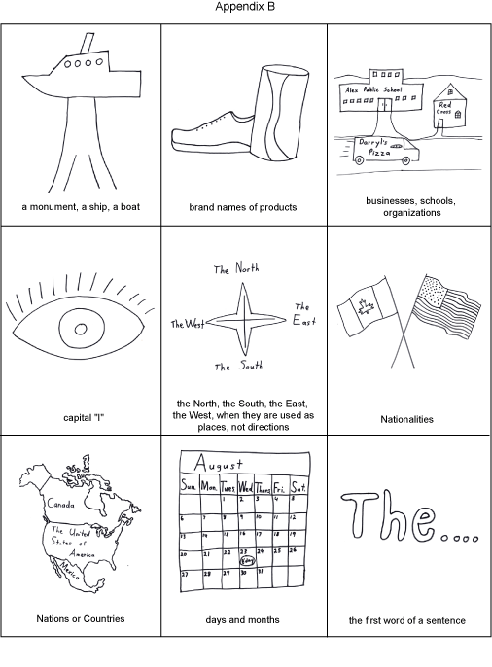
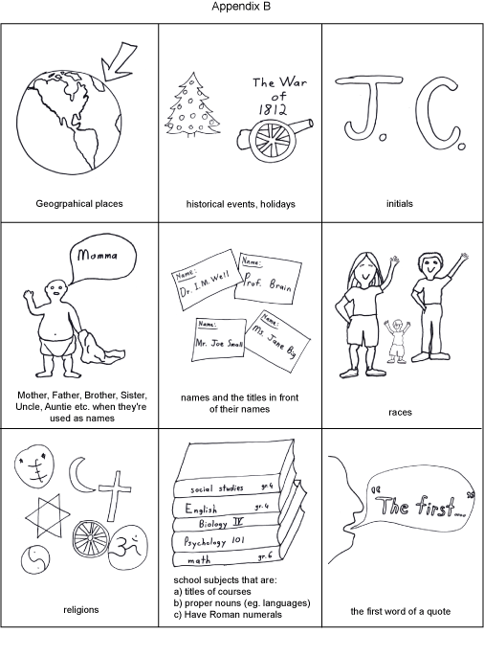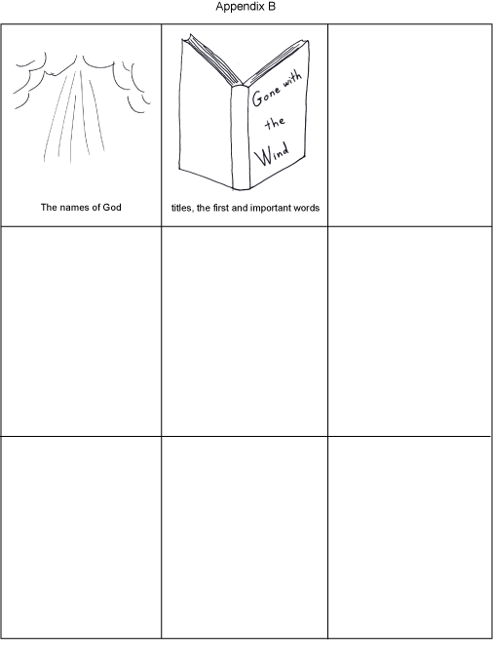
the Titanic  the Statue of Liberty  the U.S.S. Enterprise  (monument, ships, boats) | Nike  Coca-Cola  The Gap  (brand names of products) | Pizza Pizza  Sir William Osler P.S.  The Red Cross  Doctors Without Borders  (businesses, schools, organizations)
… one day I was walking….  …when I look at you I …  ( capital I ) | I used to live in the North…  When I was in the South…  (north south, east or west, when they’re used as places)  not:  We are travelling north… | The Canadians beat the Americans to win the gold medal in the 2010 Olympics.  ( nationalities )
The United States of America  Canada  Great Britain  The Democratic Republic of the Congo  (countries, nations) | Sunday, Monday, Tuesday….  April, May, June……  (days and months) | The other day I …..  It was a dark and stormy night…..  When the wolf howl at….  (the first word of a sentence)

Algonquin Park  The Grand Canyon  Baffin Island  (geographical places) | World War Two  The Battle of Britain  Christmas  Thanksgiving  (historical events, holidays) | J.C.  A.S.A.P.  (initials)
Hi Mom,, how are you?  Father, can you lend me some money?  (mother, father, aunt, uncle, brother, sister, etc. when they’re used as names )  not  My uncle is tall. | Dr. Carey  Mr. Crone  Uncle Joe  Wayne Gretzky  Bobby Orr  (names and titles in front of their names) | African American  Black  Caucasian  White  Asian  (races)
Christianity / Christian  Buddhism / Buddhist  Islam / Muslim  Baha’i  Hindu  Sikh  Judaism / Jew  (religions)  God  Allah  Yahweh  (the names of God) | Next year I will take Psychology 101  I like English and French  I passed Algebra II  school subjects that:  - are Titles of courses  - are Proper nouns, e.g. languages  - have Roman numerals | “Hi,” said Luke, “do you want some ice-cream?”  “Sure,” I replied.  ( the first word of a quote)

Gone with the Wind

Twilight

Harry Potter and the Goblet of Fire

( the first and important words of titles )

